Query Document for Financial Loan Report

Report Requirements:

* Total Loan Applications:

SELECT COUNT(*) AS Tot_loan_Apps FROM financial_loan;



* Total Loan Applications per Month:

SELECT month(issue_date) as Month, COUNT(id) AS Tot_loan_Apps FROM financial_loan

GROUP BY month(issue_date)

ORDER BY month(issue_date);

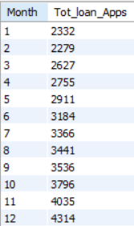

* Month over Month Growth Percentage of Loan Applications:

WITH cte AS(

SELECT MONTH(issue_date) as Month, COUNT(id) AS Tot_loan_Apps

FROM financial_loan

GROUP BY MONTH (issue_date)

ORDER BY MONTH (issue_date)),

cte2 as (

SELECT Month, LAG(Tot_loan_Apps,1,0) OVER(order by month) AS Prev_month

FROM cte)

SELECT cte.Month, (Tot_loan_Apps - Prev_month)*100.0/Prev_month as MoM

FROM cte

JOIN cte2 ON cte2.Month = cte.Month;

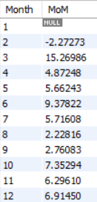

* Total Funded Amount by the Bank:

SELECT SUM(loan_amount) AS Tot_amt_funded

FROM financial_loan;



* Month over Month Growth Percentage of Funded Amount:

WITH cte AS(

SELECT MONTH(issue_date) as Month, SUM(loan_amount) AS Funded_amt_per_mon

FROM financial_loan

GROUP BY MONTH (issue_date)

ORDER BY MONTH (issue_date)),

cte2 as (

SELECT Month, LAG(Funded_amt_per_mon,1,0) OVER(order by month) AS Prev_month_funded_amt

FROM cte)

SELECT cte.Month, (Funded_amt_per_mon - Prev_month_funded_amt)*100.0/Prev_month_funded_amt as MoM_funded_amt

FROM cte

JOIN cte2 ON cte2.Month = cte.Month;

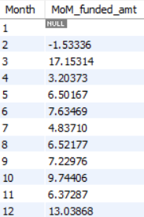

* Total Amount Received by the Bank:

SELECT SUM(total_payment) as tot_amt_rec

FROM financial_loan;



* Payment Received Month over Month Percentage:

WITH cte AS(

SELECT MONTH(issue_date) as Month, SUM(total_payment) AS rec_amt_per_mon

FROM financial_loan

GROUP BY MONTH (issue_date)

ORDER BY MONTH (issue_date)),

cte2 as (

SELECT Month, LAG(rec_amt_per_mon,1,0) OVER(order by month) AS Prev_month_rec_amt

FROM cte)

SELECT cte.Month, (rec_amt_per_mon - Prev_month_rec_amt)*100.0/Prev_month_rec_amt as MoM_rec_amt_perc

FROM cte

JOIN cte2 ON cte2.Month = cte.Month;

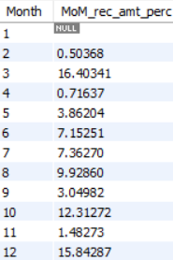

* Average Interest Rate:

SELECT ROUND(AVG(int_rate),4) as avg_int_rate

FROM financial_loan;



The average interest rate is 12%

* Average Interest Rate per Month:

SELECT MONTH(issue_date) as Month, CAST(AVG(int_rate)*100 AS DECIMAL(4,2)) AS avg_int_rate

FROM financial_loan

GROUP BY MONTH (issue_date)

ORDER BY MONTH (issue_date);

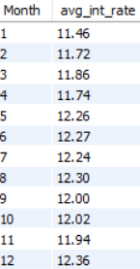

* Average Debt to Income Ratio:

SELECT ROUND(AVG(dti),4) AS avg_dti

FROM financial_loan;



* Categories In Loan Status:

SELECT DISTINCT loan_status

FROM financial_loan;

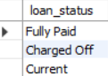

Among these, fully paid and current are considered as good loans while charged off is considered as bad loan.

* Good Loan Percentage:

SELECT ROUND(COUNT(CASE

WHEN loan_status = 'Fully Paid' OR loan_status = 'Current' THEN id END)*100.0/COUNT(id), 2)

AS good_loan_perc

FROM financial_loan;



* Good Loan Applications:

SELECT COUNT(id)

FROM financial_loan

WHERE loan_status IN ('Fully Paid' ,'Current');



* Good Loan Funded Amount:

SELECT SUM(loan_amount) AS good_loan_funded_amt

FROM financial_loan

WHERE loan_status IN ('Fully Paid' ,'Current');



* Good Loan Amount Received:

SELECT SUM(total_payment) AS good_loan_rec_amt

FROM financial_loan

WHERE loan_status IN ('Fully Paid' ,'Current');



* Bad Loan Percentage:

SELECT ROUND(COUNT(CASE

WHEN loan_status = 'Charged Off' THEN id END)*100.0/COUNT(id), 2)

AS bad_loan_perc

FROM financial_loan;



* Bad Loan Applications:

SELECT COUNT(id) AS bad_loan_tot_apps

FROM financial_loan

WHERE loan_status = 'Charged Off';



* Bad Loan Funded Amount:

SELECT SUM(loan_amount) AS bad_loan_funded_amt

FROM financial_loan

WHERE loan_status = 'Charged Off';



* Bad Loan Amount Received:

SELECT SUM(total_payment) AS bad_loan_rec_amt

FROM financial_loan

WHERE loan_status = 'Charged Off';



* Metrics Grouped by Loan Status:

SELECT loan_status, COUNT(id) as loan_apps, SUM(loan_amount) as amt_funded,

SUM(total_payment) as amt_received, AVG(int_rate) as avg_int_rate,

AVG(dti) as avg_dti

FROM financial_loan

GROUP BY loan_status;

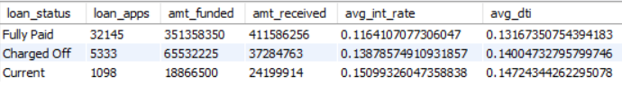

* Report Overview w.r.t Month:

SELECT DATE_FORMAT(issue_date, '%M') as month, MONTH(issue_date) as month_no,

COUNT(id) as loan_apps, SUM(loan_amount) as tot_amt_funded,

SUM(total_payment) as tot_amt_received

FROM financial_loan

GROUP BY DATE_FORMAT(issue_date, '%M'),MONTH(issue_date)

ORDER BY MONTH(issue_date);

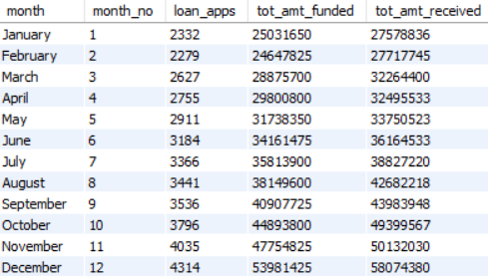

* Report Overview w.r.t Term:

SELECT term, COUNT(id) AS loan_Apps, SUM(loan_amount) AS tot_amt_funded,

SUM(total_payment) AS tot_amt_received

FROM financial_loan

GROUP BY term

ORDER BY COUNT(id) DESC;

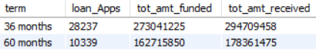

* Report Overview w.r.t States(top 10 states with highest total amount received):

SELECT address_state AS State, COUNT(id) AS Total_Loan_Applications,

SUM(loan_amount) AS tot_amt_funded, SUM(total_payment) AS tot_amt_received

FROM financial_loan

GROUP BY address_state

ORDER BY COUNT(id) DESC

LIMIT 10;

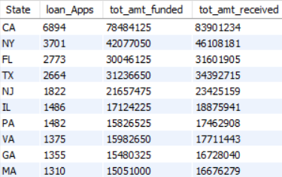

* Report Overview w.r.t Employee Length:

SELECT emp_length , COUNT(id) AS loan_Apps, SUM(loan_amount) AS tot_amt_funded,

SUM(total_payment) AS tot_amt_received

FROM financial_loan

GROUP BY emp_length

ORDER BY COUNT(id) DESC;

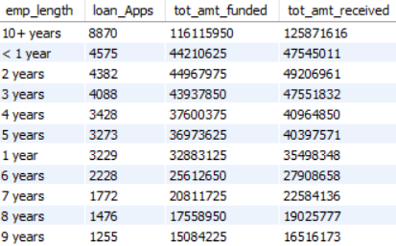

* Report Overview w.r.t Purpose of taking Loan:

SELECT purpose , COUNT(id) AS loan_Apps, SUM(loan_amount) AS tot_amt_funded,

SUM(total_payment) AS tot_amt_received

FROM financial_loan

GROUP BY purpose

ORDER BY COUNT(id) DESC;

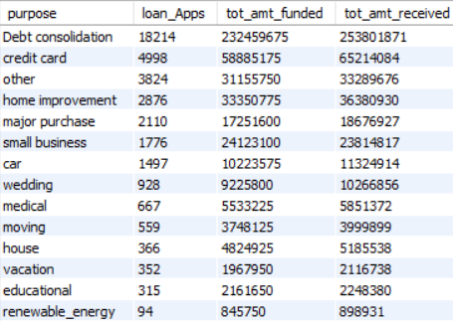

* Report Overview w.r.t Home Ownership:

SELECT home_ownership , COUNT(id) AS loan_Apps, SUM(loan_amount) AS tot_amt_funded,

SUM(total_payment) AS tot_amt_received

FROM financial_loan

GROUP BY home_ownership

ORDER BY COUNT(id) DESC;

